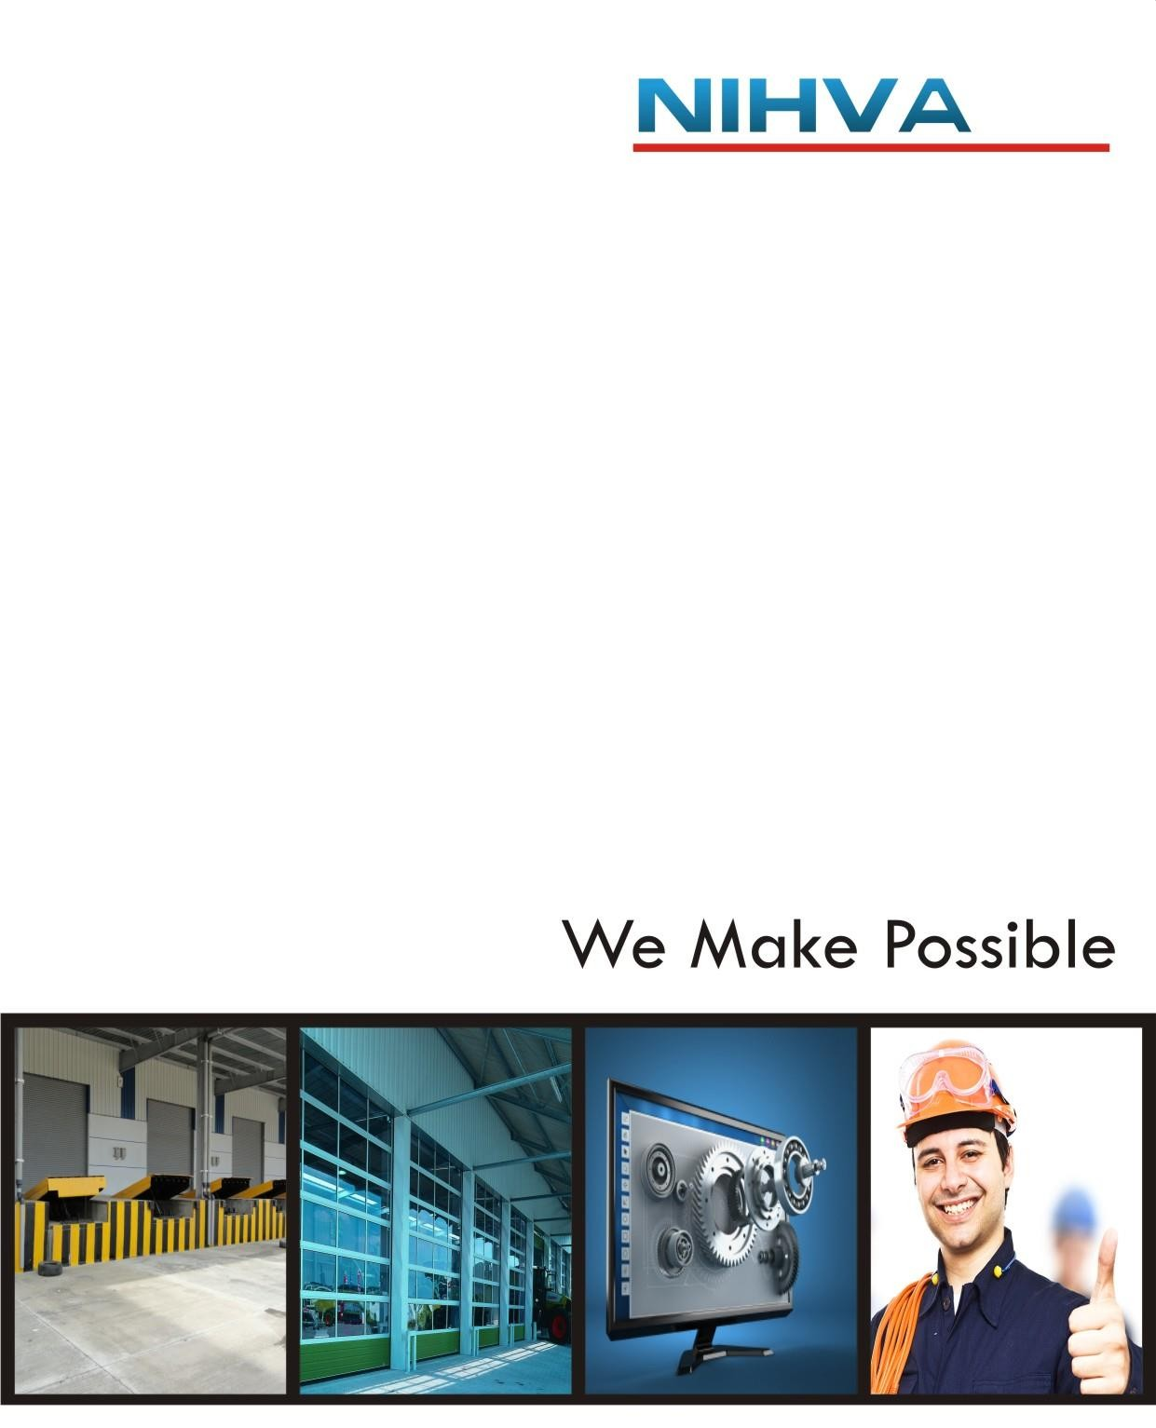

OPERATION - MAINTENANCE MANUAL FOR
TELESCOPIC SLIDING DOOR

TELESCOPIC SLIDING DOOR
SIZE | Width 20000xHeight 4500 mm
SR. NO. | NHSD1018
CLIENT | M/s. Shree Pre Fab Steels Pvt. Ltd

OPERATION -MAINTENANCE MANUAL FOR
PIT MOUNTED HYDRAULIUC SCISSOR LIFT

PIT MOUNTED HYDRAULIUC SCISSOR LIFT
Size | W 2000 MM X L 3000 MM
Sr. No. | NMSL1075
Client | AL RAHA AUTOMATIC DOORS LLC

ACKNOWLEDGEMENT LETTER
Date:

To,
The Project Manager
AL RAHA AUTOMATIC DOORS LLC
Project – PIT MOUNTED HYDRAULIUC SCISSOR LIFT

Kindly find the below list of documents.

- General information
- Electro hydraulic scissor lift- do’s & dont’s
- operating instruction
- Lubrication and routine maintenance instruction
- Guidelines in case of oil leakage
- Trouble shooting guidelines
- General safety instruction
- Electrical wiring diagram
- Hydraulic circuit diagram
- GA Drawing
- Contact escalation chart

For NIHVA Technology Pvt Ltd. Received By

Contents:-

- General information

- Electro hydraulic scissor lift- do’s & dont’s

- operating instruction

- Lubrication and routine maintenance instruction

- Guidelines in case of oil leakage

- Trouble shooting guidelines

- General safety instruction

- Electrical wiring diagram

- Hydraulic circuit diagram

- GA Drawing

- Contact escalation chart

Company Profile

“NIHVA” pioneers in offering intelligent, innovative and economical ‘Solutions’. We are proud of our products and service range offered with a high level of working safety, comfort, functionality and supported by value added solutions & services.
“NIHVA” specializes in providing integrated solutions in Door automation, customized material handling solutions, factory and warehouse automation, Roof and Window automation, Mobile warehouses Apart from this , for any project our scope commences from under-standing the requirement, functionality, designing & solution to installation and commissioning. Further we prefer to be with you by providing a service backup for a ‘commitment beyond contract’.

NIHVA Business activities divided in 3 divisions.
- Door Automation
- Material Handling Equipment
- Automation solution

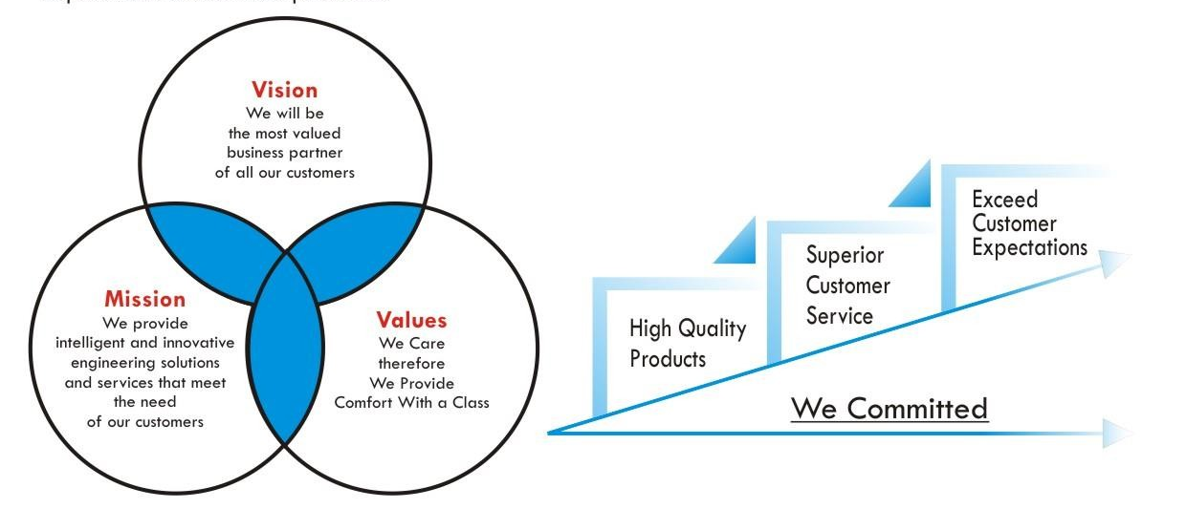

Our Mission
We are a customer-centric organization committed to deliver quality products and services efficiently and on-time. Our mission is to deliver single source of innovative engineering solutions, automation products and services, and world- class service support.
We strive to implement next-generation technologies and solutions for our customer needs, thus helping them to derive maximum benefit of their investments.
We fulfil our mission through some core values that have become the lifeline of our organization.

Quality Policy

State-of-the-art, Innovative, High Quality Products
World-class, Superior, Customized and Always-Ready Customer Service and Support

Overachieve and Exceed Customer Expectations
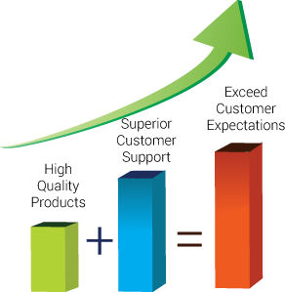

DOOR Automation:

‘NIHVA’ has always been strongly supported by world leaders in automation brands representing & serving world’s best brands like AssAbloy, Megadoor- crawbord,ACO & many more.
With wide experience in the field of door automation and strong technical, installation & service back up, we can offer various automatic doors like sliding folding doors, sectional doors, high speed doors and hanger doors. We can also offer special customized doors.
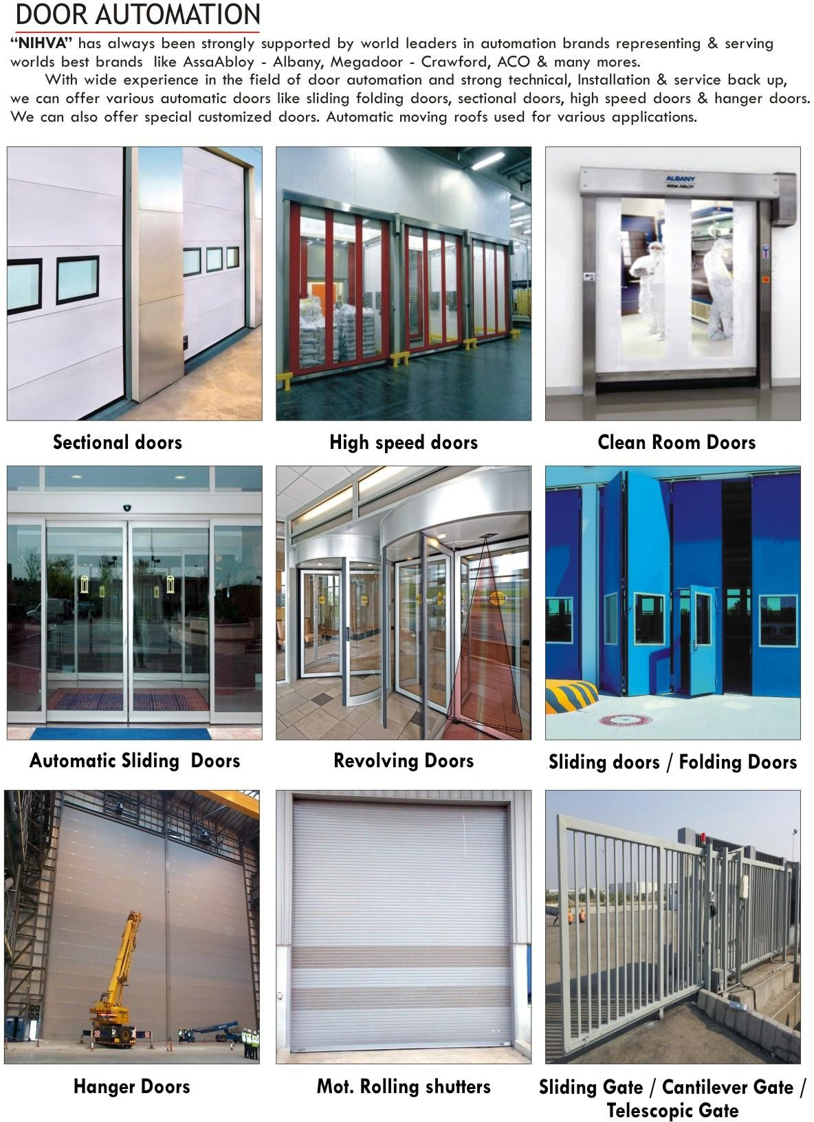

Material Handling Equipment
“NIHVA”- Material handling division provides ideal solution for your material movement, lifting, driving & tilting issues, palletizing loads for various industrial and warehousing applications.
We are pioneers inn warehouse technology, with advance warehouse equipment’s and software we create simple logistics solutions for your ware house and factory considering your special requirements.
We are pioneers in warehouse technology, with advance warehouse equipment and software. We create simple logistics solution for your warehouse and factory considering your special requirements.
We offer Dock leveller, Scissor lift, towing truck, electric pallet truck, electric stackers, maintenance work platforms, goods lift and telescopic conveyors as per application need.
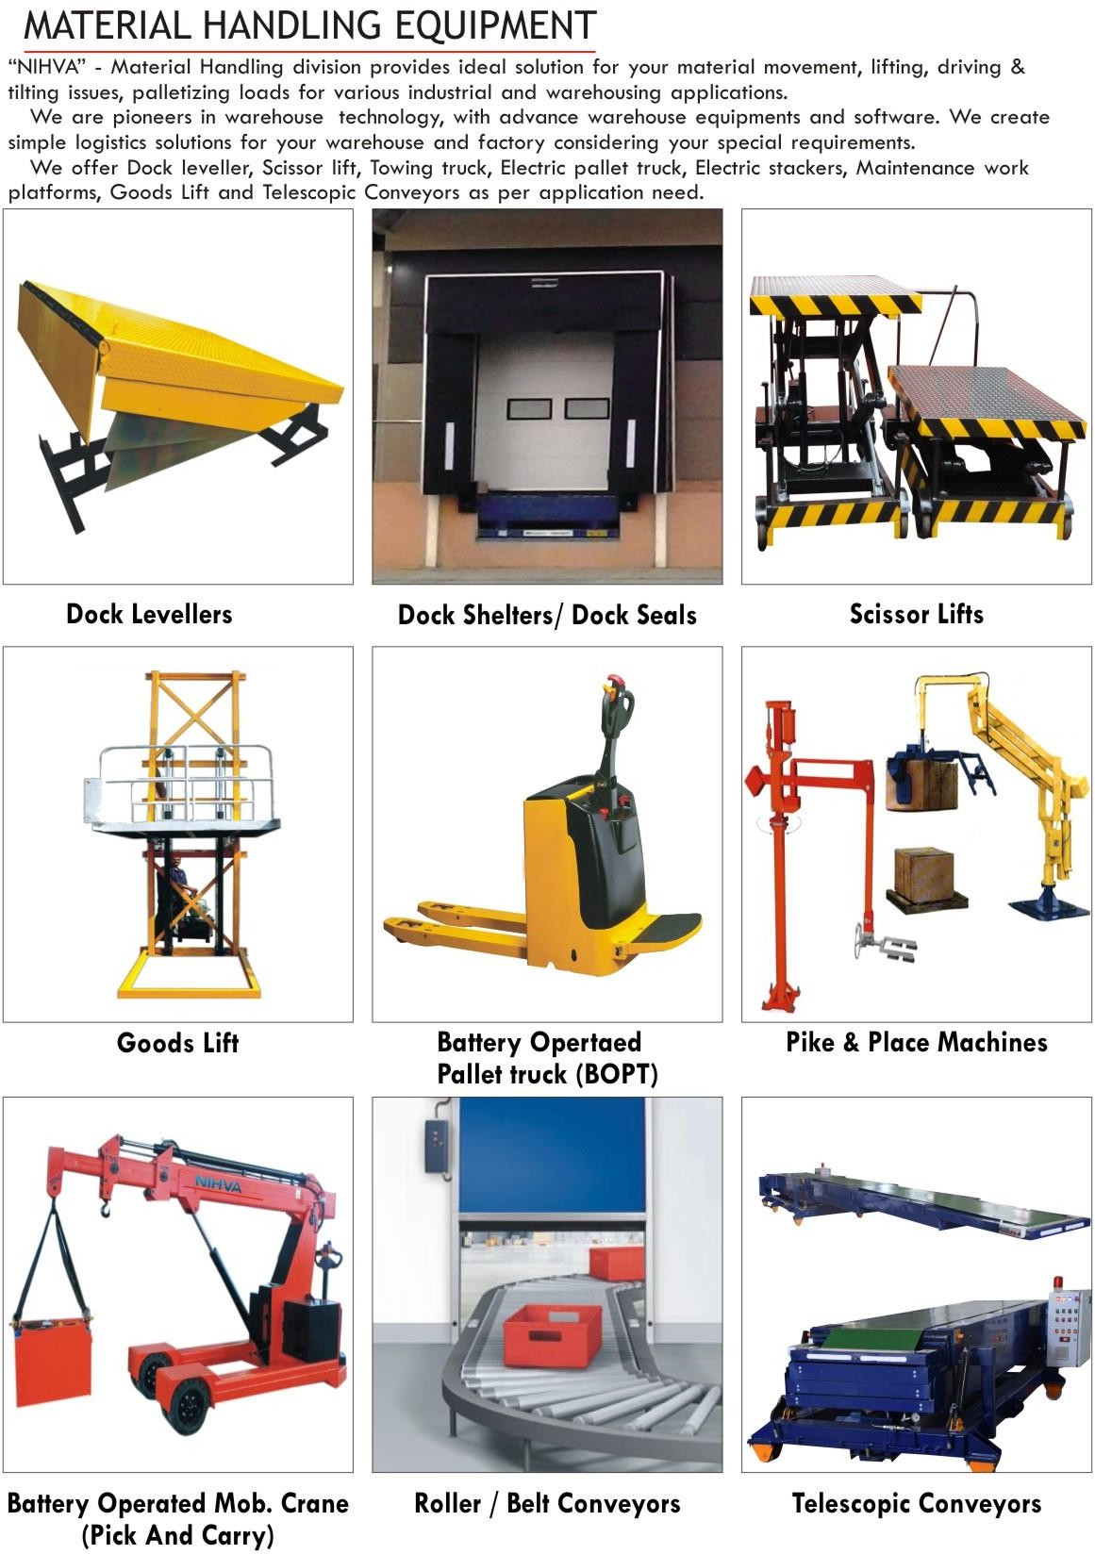
Automation Solutions:-
- Robotics integration - part
- Sorting
- SPM
- Machine communication and automation software.
- Palletizing
- Pick & place manipulators and various assembly
- Wireless automation (M&M) - monitor, command and control various parameters remotely.
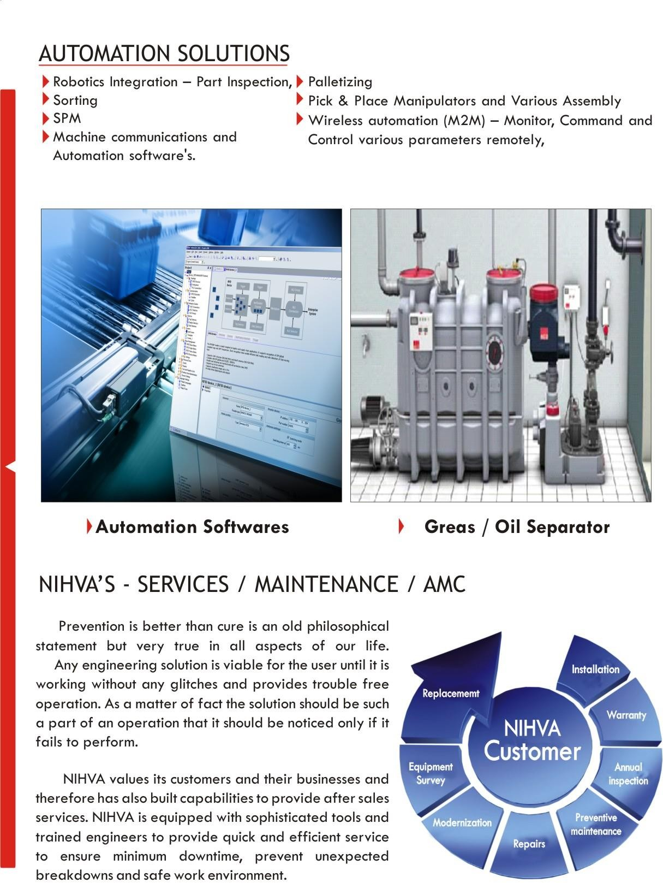

NIHVA’s Service / Maintenance / AMC
Prevention is better than cure is an old philosophical statement but very true in all aspects of our life.
Any engineering solution is viable for the user until it is working without any glitches and provides trouble free operation. As a matter of fact the solution should be such a part of an operation that it should be noticed by if it fails to perform.
NIHVA values its customers and their businesses an therefore has also built capabilities to provide after sales services, NIHVA is equipped with sophisticated tools and trained engineers to provide quick and efficient service to ensure minimum downtime, prevent unexpected breakdown and safe work environment.
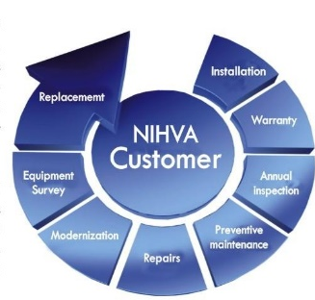

Method statement for pit mounted scissor lift:

1. Check all pit dimensions for accuracy.
2. Attach a temporary electrical line through the pit conduit to the lift. Check for correct motor rotation
3. Using slings, encircle the entire lift, not just the platform and lower the lift into the pit, centering it for 1” minimum clearance on all sides to the pit wall.
4. Raise the lift with the push button and remove the slings. Run the unit up and down several times to remove air from the hydraulic system.
5. Level and center the lift by shimming and grouting the entire base frame, not just the corners. Lag the unit in place using M16 x 150L wedge anchors in the holes provided. Caution! Continuous base frame support is essential for proper installation
6. With the lift fully elevated, disconnect the main power and complete the permanent electrical wiring.
7. Follow the instructions outlined in operating manual to complete the installation.

GENERAL INFORMATION
- The hydraulic scissor lift load capacity rating and the serial number is mentioned on metal name plate.
- Caution- Before Start the scissor lift Operation It is Very Important to remove all 4 Eye Bolts Other Wise Scissor Bed get Damage.
- Lift should not be overloaded beyond the rated load capacity may result in damage.
- The hydraulic system consists of pump, motor, oil tank & valves.
- The gear pump is set at operating pressure of 150 bar.
- The operating principle is that the pump is operated to raise the table, and the pump is stopped when the table attains the desired elevation. A check valve and lowering valve between the pump and cylinder holds the table at elevation. For lowering to any desired level, the solenoid valve is energized to allow fluid to return from hydraulic cylinder to reservoir. A pressure compensated flow control valve is connected to the hydraulic cylinder to control the down speed at a predetermined rate under all load conditions.
- A scissor lift should only be operated on a solid surface such as concrete, tile, or a compacted road base. When lifts are placed on uneven surfaces or earth, mulch or gravel that is not compacted, the lifts may tip and fall over, causing serious injury or death to the people on the platform.
A) Maximum Load Lifting Capacity | 3000 KG
B) Max Height of Platform | 1900MM
C) Actual Lift | 1300 MM
D) Min Height of Platform | 600 MM
E) Platform Length | 3000 MM
F) Platform Width | 2000 MM
G) Motor Capacity | 3HP
H)Railing | 900 MM
1.1 MAIN SPECIFICATIONS

2. ELECTRO HYDRAULIC SCISSOR LIFT- DO’s & DONT’s: -

DOs: -
- Check all the electrical connections.
- Check the hydraulic connections.
- Ensure NO Oil Leakage from joints.
- Ensure the oil level on level indicator before using the lift.
- Before loading & unloading ensure the lip rests on truck properly.
- Ensure that there isn’t any obstacle within the region of moving parts.
- While doing maintenance work, ensure that the Emergency switch is pressed & the maintenance stoppers are in their position while working below the lift.
DON’Ts: -

- Lift should not be loaded beyond its rated load capacity.
- Don’t lose the oil hoses without resting the lift on its maintenance stoppers.
- Do not operate damaged lift.
- Don’t stand at the edges of lift platform while the lift is lowering.
- Don’t change lowering valve setting without supervision or any assistance.
- In case of power failure, to resume the downward operation after Power ON, do not lower the lift. Instead, take the lift slightly upward & then resume to lower it.
- Don’t put any manual stopper or anything in the roller track.

3. OPERATING INSTRUCTIONS

- Check all electrical connection for short or phase short. Check hydraulic connections are tightened properly to ensure no oil leakage from joints.
- Connect (3 phase 415V) supply to the panel through cable top.
- Switch ON the RED LOTO SWITCH on panel & ensure Emergency push button is in unlock position.
- Use Lift’s PUSH BUTTONS for moving lift upward & downward.
- Use Lip’s PUSH BUTTONS for moving lip upward & downwards.
- In case of emergency, press emergency STOP push button provided on push button station.
- Before lifting Scissor, check motor rotates in clock wise direction.
- For controlling the lowering speed, adjust the valve provided on manifold.
- In case of failure & scissor lift platform is at top position, loosen the threads of manual override provided in the solenoid valve after reaching the platform at down position again retighten the same.

4. LUBRICATION & ROUTINE MAINTENANCE INSTRUCTIONS


- Lubrication Points
Lubrication points as mentioned below,
A. Points noted with ‘A’, apply grease lubrication.
B. Points noted with ‘B’, apply oil lubrication.
C. Points noted with ‘C’, no lubrication required (Pre-Lubricated &sealed)
D. Ensure all Moving parts like Wheel, Flap Joint, Rollers etc. are greased.
- Inspection Check Points

- Visually inspect all jack pins, pivot pins to ensure that the
set screw has not loosened, allowing pins to move.
- Confirm Hex Nut Bolt, Allen Bolt -Pivot Pin Locking Are Fixed firmly.
- Confirm Grub screw, Cup Washer on Scissor Arm Joint Bolt are fixed & are tightened firmly.
- Confirm Tightening of Rollers & its free movement.
- Confirm all Bolts at Scissor Arm are tightened.
- Visually inspect all lift arm rolling bearings to ensure that bearing bolts are tight.
- Visually inspect all hydraulic hoses and fittings to ensure there are no cut on hoses or leaking fittings.
- Visually inspect all electrical lines to ensure there are no cut wires or loose cords.
- Visually inspect the entire lift structure.
- These recommendations are applicable to the equipment considering daily usage of approx. 15-to 20 times.

If usage is more frequent, the same time intervals for maintenance should be adjusted accordingly.
- WEEKLY
- Do greasing / oiling of all moving joints.

- MONTHLY
a) Check hydraulic pipeline for leak proof working.
b) Check oil level in hydraulic tank.
c) Check cylinder seals & ‘O` rings for leak proof working.

- YEARLY
a) Change hydraulic oil.
b) Check main shaft seal & shaft ‘O` ring for leak proof working.

Hydraulic oil to be used – Enclo – 68 OR Servo – 68.

5. GUIDE LINES IN CASE OF OIL LEAKAGE
- Leakage at Piping –
    - Tighten Joints.
    - Replace Dowty Seal at Mounting
- Leakage in Cylinder-
- Replace Seals.
- Replace Oil after Every Year-
- Drain the Oil from the System.
- Clean filter, Tank elements, and strainers before refilling.

6. TROUBLE SHOOTING GUIDELINES

- If lift will not raise:
a. Check electric circuit on new installations of 3-phase motors, if lift does not start raising in approximately 10 seconds, reverse two power supply leads to reverse pump rotation. (if motor direction is reverse)
b. Check oil level. With lift in full up position, oil level should be
Approximately 11⁄4" above tank bottom.

- Lift raises slower than specified rate or will raise only partial load:
Note: Allowance must be maintained for slight speed variations (due to temperature which changes the viscosity of the hydraulic oil varies)
a. Check line voltage under load condition. Low voltage affects capacity of equipment.
b. If foam is visible in tank oil, check for a loose connection in suction line between pump and tank. Tighten connections.

iii. Lift slowly settles with lowering valve not energized:
a. Flush lowering valve by cycling lift up and down. This should be done with no load.
b. If lift continues to settle, replace down valve cartridge.
c. If lift continues to settle, replace pump.

iv. If Lift will not lower:
a. Look for mechanical restrictions.
b. Test valve coil for operation. Check voltage at coil.
c. If voltage is ok, replace coil.

v. If lift will not raise to full vertical travel:
a. Check for low oil level if necessary, add oil.

vi. If lift does not lower smoothly:
- Run the lift up and down under load condition for some time to purge air.

7.GENERAL SAFETY INSTRUCTIONS
Use trained personnel for loading & unloading of equipment. The equipment must be properly handled when transferring from the unloading area to final site to prevent damage.
DO NOT operate equipment unless it is properly anchored. It may cause serious injury or death.
- Install all safety devices, guards and guarding prior to equipment start-up.
- Only Trained & Authorized person must use the lift.
- Always use mechanical stopper if you are going to work in elevated condition.
- Keep working area free from oil to Avoid Slipping/Fire hazards.
- Do Not Exceed the Lift Capacity than rated.
- Before cleaning or servicing disconnect power supply
- As the lift moves up and down, “pinch points” are formed. Keep hands, feet, hair, loose clothing, etc. away from these pinch points. Any of these may cause serious personal injury or death.
- Ensure that the hydraulic, pneumatic and electrical lines will not be pinched by the lift as it rises or lowers. If a line gets pinched, the lift may not work properly. A hose may break, the lift table may drop suddenly, and someone may get injured. If an electrical line is broken, may cause personal injury or death due to electrical shock.
- Read the motor nameplate and record the motor full load current. Consult local electrical codes for power supply fusing requirements. To avoid fire hazards, follow these fusing requirements.



8 ELECTRICAL WIRING DRAWING



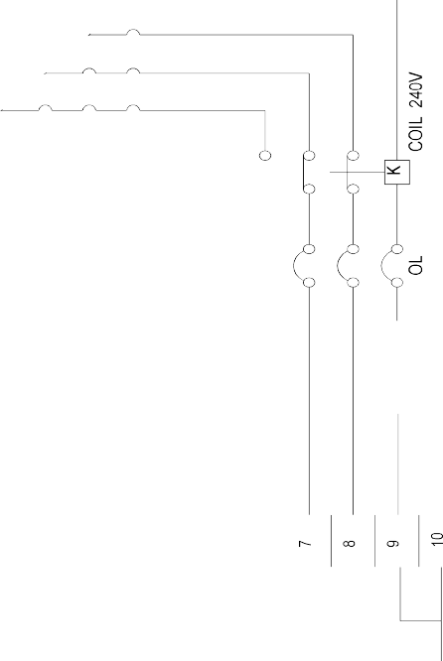

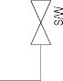


9.Hydraulic :
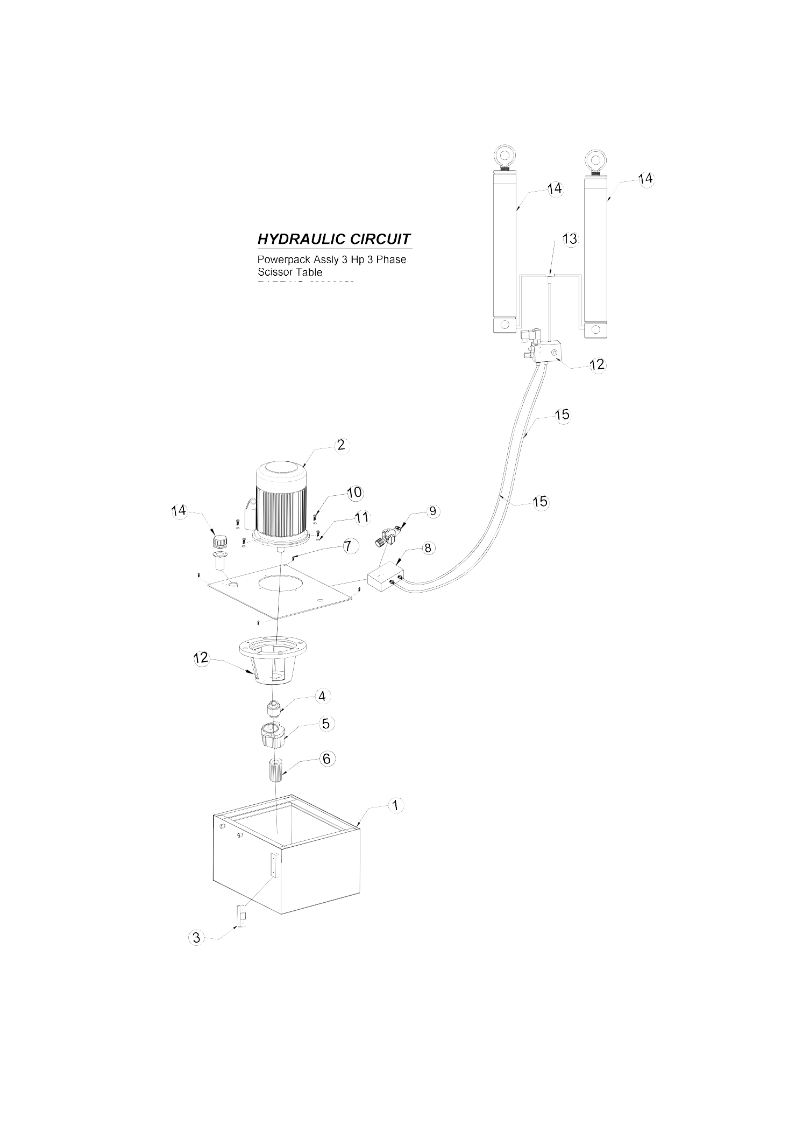

MANUAL SCISSOR LIFT TABLE

10. Approved GA Drawing
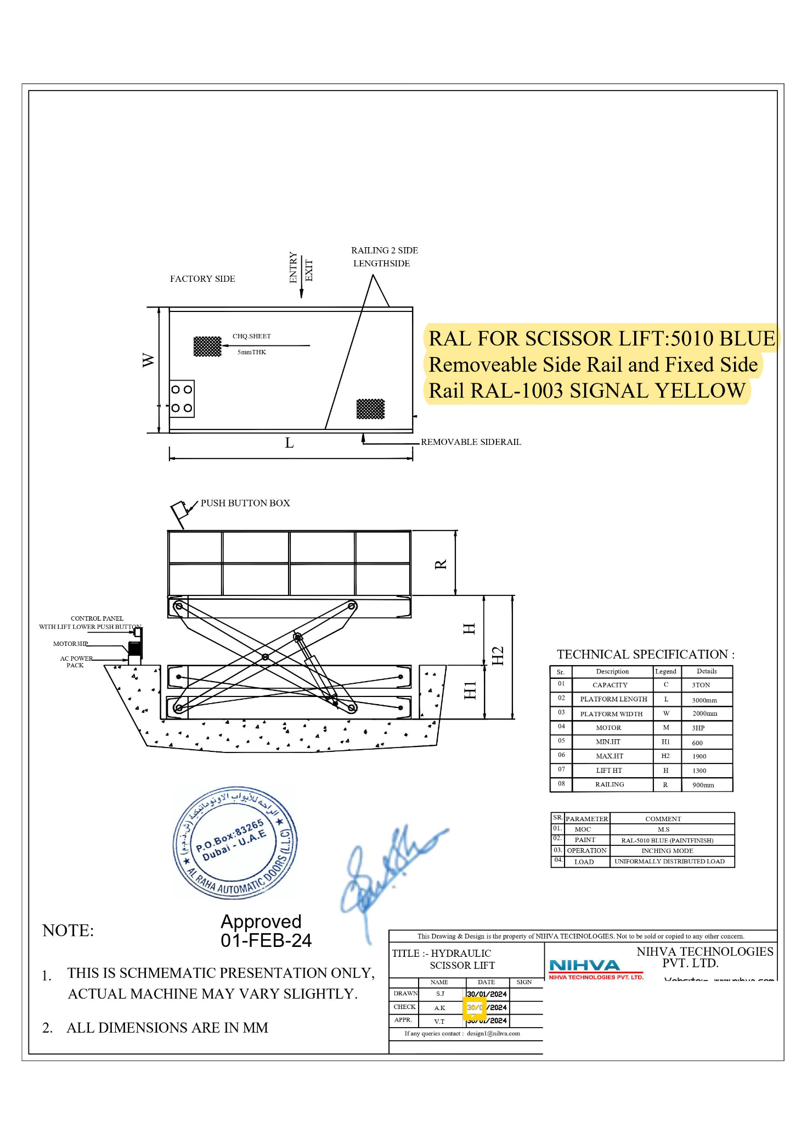
11. CONTACT ESCALATION CHART

Sr.No | Dept. | Representative | Mobile | E-mail ID
1 | Service | Mr. Kaustubh Kathale | 9168938333 | service@nihva.com
2 | Projects | Mr. Sandeep Mandawade | 7410195333 | projects@nihva.com
3 | Operation | Mr. Rohit Shinde | 7709209333 | planning@nihva.com
4 | Sales Coordination | Mr. Shailesh Bhoir | 8551091333 | information@nihva.com
5 | G.M. | Mr. Amit Kurhade | 7410172333 | amit.kurhade@nihva.com



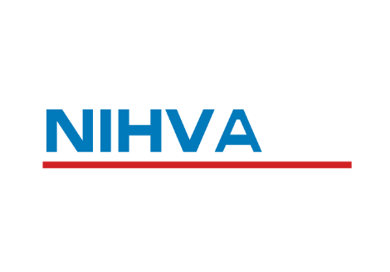

sales@nihva.com
NIHVA TECHNOLOGIES PVT. LTD.
Head Office: 187, G-Block, 1st Floor, Thermax Chowk,
MIDC, Above Kotak and Saraswat Bank, Chinchwad
Pune - 411019
+91 2066 3040 33
+91 85 51091 333
www.nihva.com
www.shivaah.com

Mercedes Benz Indian Pvt Ltd
GE CHAKAN
Volkswagen, Chakan
lndospace lndustrial Park Pune Pvt ltd
RVK Industrial Park Pvt Ltd
SCON Projects
Apollo power systems pvt.ltd
Barry Callebaut lndia Pvt Ltd
KVR Industrial Park Pvt Ltd
Neuman & Esser Engineering ( l) Pvt Ltd
Elring Klinger Automotice Components India Pvt Ltd
PHENIX INFRA
Ingarsoll Rand (I) Pvt. Ltd.,
PMP Drive Systems lndia pvt.Ltd.
SMCC CONSTRUCTION INDIA LTD
Hyosung T & D
Vaichal construction Pvt.Ltd
Wipro
Adani
John Deere
Glatt Systems Pvt.ltd
Ronak Build well pvt.ltd
Creative Carve
INDOCOUNT
Power Erectors
Serum
SANY

